**PART 1**

***Place a check mark next to the correct number.[1]***

***Please return the survey to the MAE Department Office after completing the course.***

1. Students showed the knowledge expected from the prerequisites

1__ 2__ 3_X_ 4__ 5__

1. The prerequisites to the course were sufficient and appropriate

1__ 2__ 3X 4__ 5__

1. All the topics specified in the course outline handed out were taught

1__ 2__ 3__ 4__ 5_X

1. The course learning objectives were the same as when last taught

1__ 2_X_ 3__ 4__ 5__

1. The classroom and laboratory facilities were adequate

1_X_ 2__ 3__ 4__ 5__

1. The students were actively engaged in the class (they asked questions, etc.)

1__ 2__ 3_X_ 4__ 5__

1. What was the average attendance?

(0-20%) 1__ 2__ 3__ 4_X_ 5__ (80-100%)

***For answers with a score of 3 or below, please provide the question number and an explanation below:***

The scale for the responses is not given. It makes it quite difficult to answer. I am assuming that a larger value is better.

1. Students did not have the necessary skills in the areas of basic algebra, dealing with fractions, basic Newton dynamics, describing motion using kinematics, scientific programming (simulating differential equations, plotting, basic computations), differential equations.

2. The prerequisites are the same as the previous year the course was taught. As a result this means that the previous courses are not preparing the students appropriately.

4. I modified the course learning objectives to cover the material I deem critical for a first course in linear systems and control theory. The material should adequately prepare students to apply the methods to the design of control systems for linear systems.

5. The classroom was a completely unacceptable. The course was held on the other side of campus in 1957 E 214 rather than in SEH. The desks were too small and there is inadequate writing space to for any technical work. The whiteboard was an insult to the entire field of engineering as it did not provide the required amount of space to effectively convey the material. Furthermore, the scheduling office, as a final insult, managed to double book my assigned room for the final with another course. Further adding insult to injury, the MAE department, the office of the Dean, and the scheduling office all combined to ensure that none of my many requests for better facitilities were considered. It’s obvious to me that the school does not understand what is required in a classroom for an engineer. It should have ample whiteboard/blackboard surface. This means 5+ meters of horizontal writing surface. Each student should have access to a large writing surface. This surface should be enough to hold four standard sheets of paper arranged however the student sees fit.

To make the situation even more clear, observe the image below. Students are cramped, forced to use their knees to hold reference material or somehow juggle several notebooks, textbooks and the exam all while attempting to do techinical work.

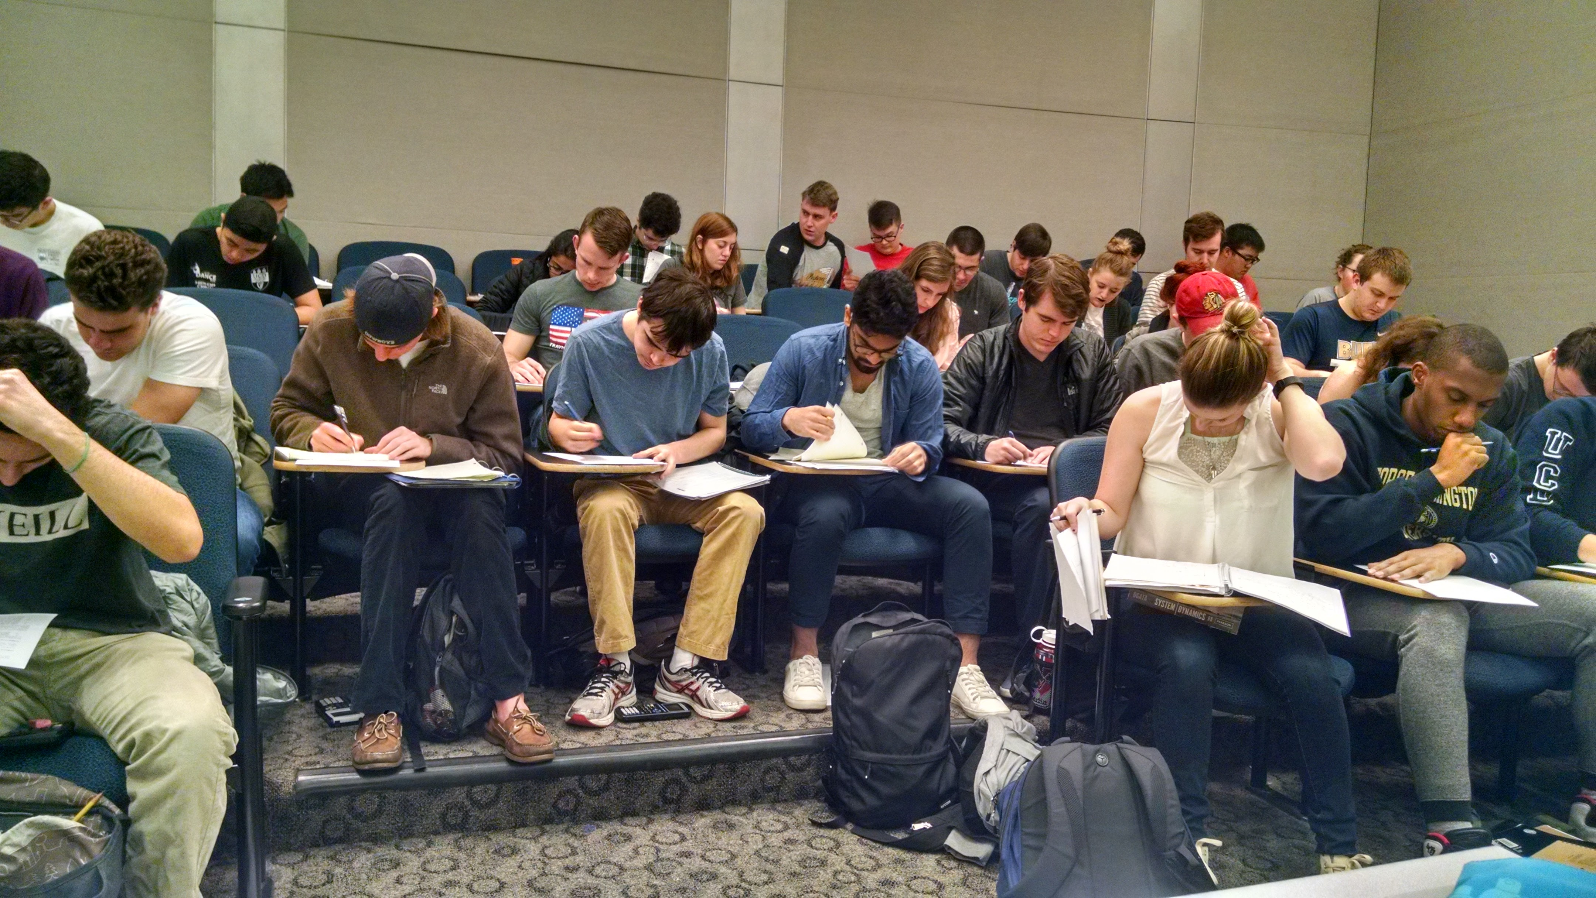

**PART 2**

A) Please complete Table 1, providing:

* in the first column the CLO (as it appears in the student online course evaluation)
* in the second column your direct assessment of each CLO (from exam question or project report)
* in the third column indirect assessment (from student online course evaluation)

**Table 1. Summary of course learning objectives assessment[2]**

|  |  |  |  |  |
| --- | --- | --- | --- | --- |
|  | CLO (Course Learning Objective) | Direct Assessment (instructor) | Indirect Assessment (student) | Student Outcome  a-k |
| 1 | Derive EOMS | 4.83 | 4.4 |  |
| 2 | Solve differential equations | 4.15 | 4 |  |
| 3 | Predict performance for linear systems | 4.31 | 4 |  |
| 4 | Bode Plot | 3.90 | 4.1 |  |
| 5 | Meet system requirements by choosing poles | 2.79 | 3.9 |  |
| 6 |  |  |  |  |
| 7 |  |  |  |  |
| 8 |  |  |  |  |
| 9 |  |  |  |  |
| 10 |  |  |  |  |

B) Please provide recommendations for course improvement (if any).

Classes should have less than 55 students for a single instructor.

Better classroom.

Students need programming experience prior to becoming a junior.

C) Please provide status of prior recommendations (if applicable)

N/A

1. Please provide assessment on a scale for from 1 to 5, where, in response to the statement given, 1=strongly disagree, 2= disagree, 3=neither, 4= agree, 5= strongly agree.
2. Please provide assessment on a scale for from 1 to 5, where, in response to the statement “the course learning objective was accomplished”, 1=strongly disagree, 2= disagree, 3=neither, 4= agree, 5= strongly agree.